CHF Steering Committees
(Table list below)
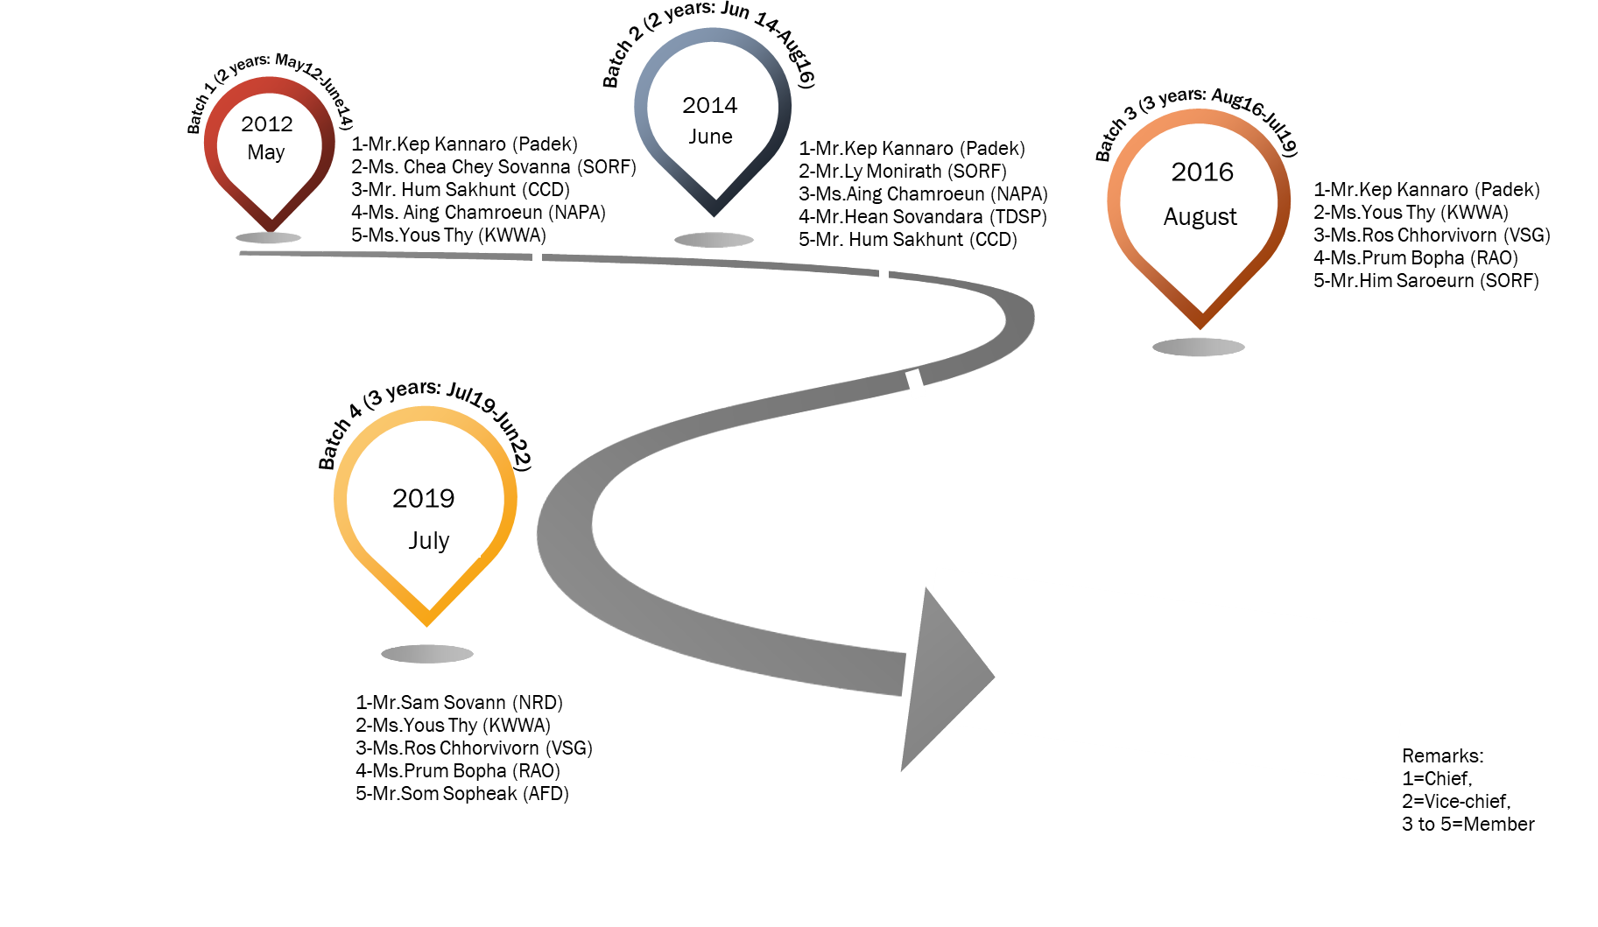

No. | Name | Roles/Position |  | Contact | Image | Secretariat
 |  | CHF Steering Committee | Institution
I | First Batch (Two-year term: May 2012-June 2014)
1 | Mr.Kep Kannaro | Chief of CHF Steering Committee | Executive Director | Institution: PADEK, Phnom Penh  Mobile: 012 858 733  Email: kannaro.kep@gmail.com | 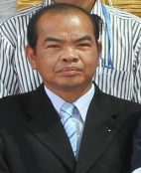 | - Mr. Sok Phoeuk​, ADPC Country Representative  - Ms. Leav Chan Kesey, National Project Assistant  - Mr. Ros Chanborith, CHF Coordinator
2 | Ms. Chea Chey Sovanna | Vice-Chief of CHF Steering Committee | Executive Director | Institution: SORF, Pursat  Mobile: 012 951631  Email: sorfdirector@yahoo.com | 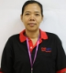
3 | Mr. Hum Sakhunt | Member of CHF Steering Committee | Executive Director | Institution: CCD, Kratie  Mobile: 012 476 834  Email: hom_sakunth@yahoo.com | 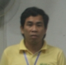
4 | Ms. Aing Chamroeun | Member of CHF Steering Committee | Executive Director | Institution: NAPA, Kampong Speu  Mobile: 092 613 587  Email: napa9396@yahoo.com | 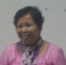
5 | Ms.Yous Thy | Member of CHF Steering Committee | Executive Director | Institution: KWWA, Kratie  Mobile: 012 916 329  Email: kwwakrt@gmail.com
II | Second Batch (Two-year term: June 2014-August 2016)
1 | Mr.Kep Kannaro | Chief of CHF Steering Committee | Executive Director | Institution: PADEK, Phnom Penh  Mobile: 012 858 733  Email: kannaro.kep@gmail.com |  | - Mr. Sok Phoeuk​, ADPC Country Representative  - Ms. Leav Chan Kesey, National Project Assistant  - Mr. Chin Vibol, CHF Coordinator
2 | Mr.Ly Monirath | Vice-Chief of CHF Steering Committee | Executive Director | Institution: SORF, Pursat  Mobile: 012 969 567  Email: monirath.ly@gmail.com
3 | Ms.Aing Chamroeun | Member of CHF Steering Committee | Executive Director | Institution: NAPA, Kampong Speu  Mobile: 092 613 587  Email: napa9396@yahoo.com
4 | Mr.Hean Sovandara | Member of CHF Steering Committee | Executive Director | Institution: TDSP, Banteay Meanchey  Mobile: 016 599 992  Email: tdsp.director@gmail.com | 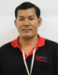
5 | Mr.Hum Sakhunt | Member of CHF Steering Committee | Executive Director | Institution: CCD, Kratie  Mobile: 012 476 834  Email: hom_sakunth@yahoo.com
III | Third Batch (Three-year term: August 2016-July 2019)
1 | Mr.Kep Kannaro | Chief of CHF Steering Committee | Executive Director | Institution: PADEK, Phnom Penh  Mobile: 012 858 733  Email: kannaro.kep@gmail.com |  | - Mr. Sok Phoeuk​, ADPC Country Representative  - Ms. Leav Chan Kesey, National Project Assistant  - Mr. Chin Vibol, CHF Coordinator  - Mr. Khun Bunna, CHF Coordinator
2 | Ms.Yous Thy | Vice-Chief of CHF Steering Committee | Executive Director | Institution: KWWA, Kratie  Mobile: 012 916 329  Email: kwwakrt@gmail.com
3 | Ms.Ros Chhorvivorn | Member of CHF Steering Committee | Executive Director | Institution: VSG, Battambang  Mobile: 077 992 270  Email: chhorvivornros@gmail.com | 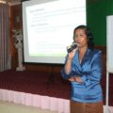
4 | Ms.Prum Bopha | Member of CHF Steering Committee | Executive Director | Institution: RAO, Svay Rieng  Mobile: 092 805 912  Email: prumbopha@gmail.com | 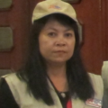
5 | Mr.Him Saroeurn | Member of CHF Steering Committee | Executive Director | Position: SORF, Pursat  Mobile: 017 707 296  Email: pcsorf@gmail.com | 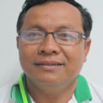
IV | Fourth Batch (Three-year term: July 2019-June 2022
1 | Mr.Sam Sovann | Chief of CHF Steering Committee | Executive Director | Institution: NRD, Kratie  Mobile: 097 777 5788  Email: sovanns@nrdo.org | 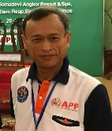 | Not identified
2 | Ms.Yous Thy | Vice-Chief of CHF Steering Committee | Executive Director | Institution: KWWA, Kratie  Mobile: 012 916 329  Email: kwwakrt@gmail.com
3 | Ms.Ros Chhorvivorn | Member of CHF Steering Committee | Executive Director | Institution: VSG, Battambang  Mobile: 077 992 270  Email: chhorvivornros@gmail.com
4 | Ms.Prum Bopha | Member of CHF Steering Committee | Executive Director | Institution: RAO, Svay Rieng  Mobile: 092 805 912  Email: prumbopha@gmail.com
5 | Mr.Som Sopheak | Member of CHF Steering Committee | Executive Director | Institution: AFD, Kampong Thom  Mobile: 092 361 206  Email: sopheak@afd-cambodia.org

